**The Grapple-Shot:**

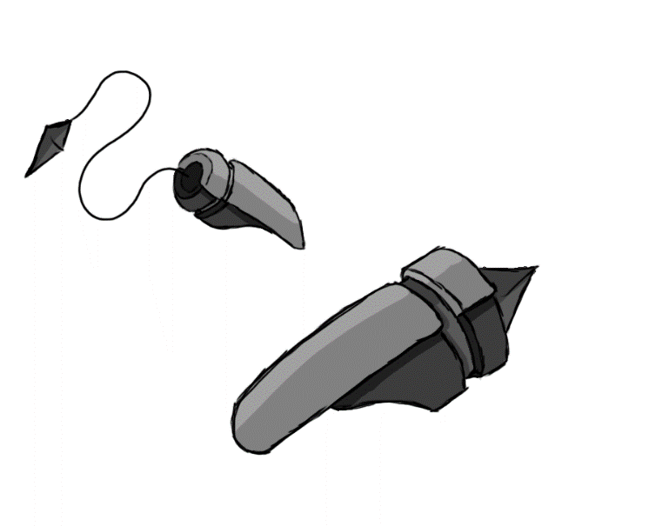

Figure 1 - Weapon: Grapple-Shot

**Brief Synopsis**

The grapple-shot is a weapon used by the player, acting as the long-range weapon of the game. The extreme range is counteracted by its exceptionally narrow arc of attack- it may only attack enemies directly in front of the player. The main use for the grapple is its ability to pull either an enemy to the player or pull the player to an enemy.

**Special Ability**

**Grapple:**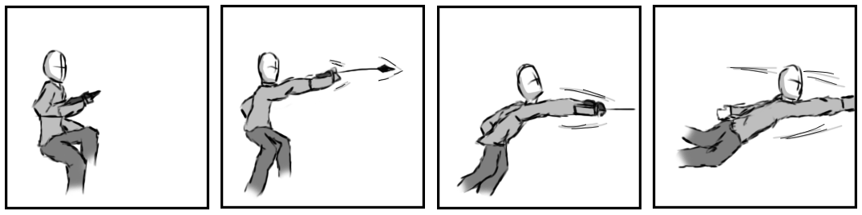

Figure - Animation Storyboard: Grapple

**Special:** This has the player shoot and pull themselves to an enemy. When in the air, an icon will appear over the nearest enemy within the grapple-shot’s range. If the grapple button is pressed the player will shoot at the enemy and pull themselves towards it. By pressing jump or attack while being pulled forward, the player will either release the grapple and jump on the enemy or kick the enemy once they reach it.

**Combat Abilities**

**Piercing shot:   
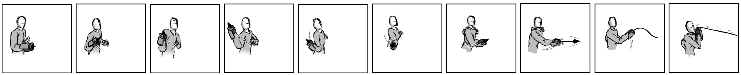  
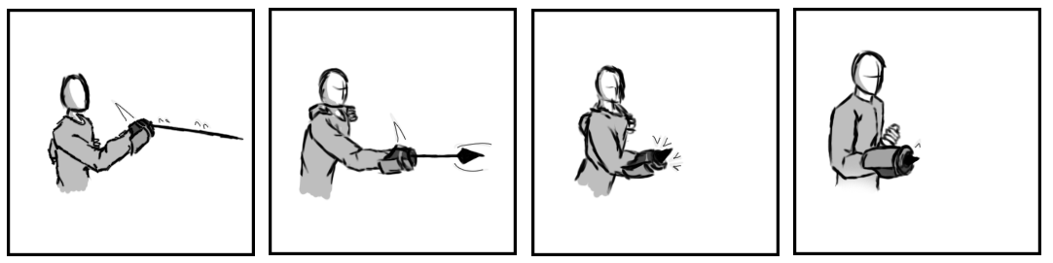**

Figure 3 - Animation Storyboard: Piercing shot

**While grounded and stationary**: The player swings the gauntlet and fires it at the peak of its arc (forwards). This will send a ranged projectile directly forwards of the player, damaging the first enemy it encounters.

**Extended Tether:  
  
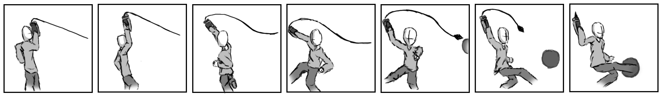**

Figure 4 - Animation Storyboard: Extended Tether

**While grounded and in motion:** Shoots a projectile, like that of the piercing shot, but if an enemy is within range it will latch onto them and pull them towards the player, stopping just in front of them. If the player presses attack during the time in which the enemy is moving towards the player, they will instead be pulled completely to the player, following up by attacking with a kick.

**Whipcrack:   
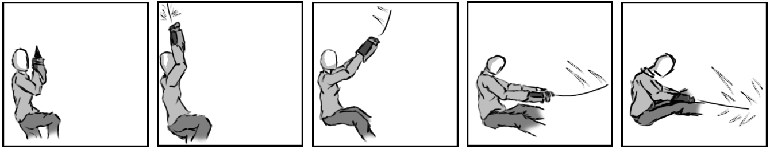**

Figure - Animation Storyboard: Whipcrack

**While aerial:** The player shoots upwards, followed by pulling the cord of the grapple straight down, as if using a whip. All enemies in the direction the player is facing will be struck.